DIS-Indo-Sumba-Ancestral stone with crocodile

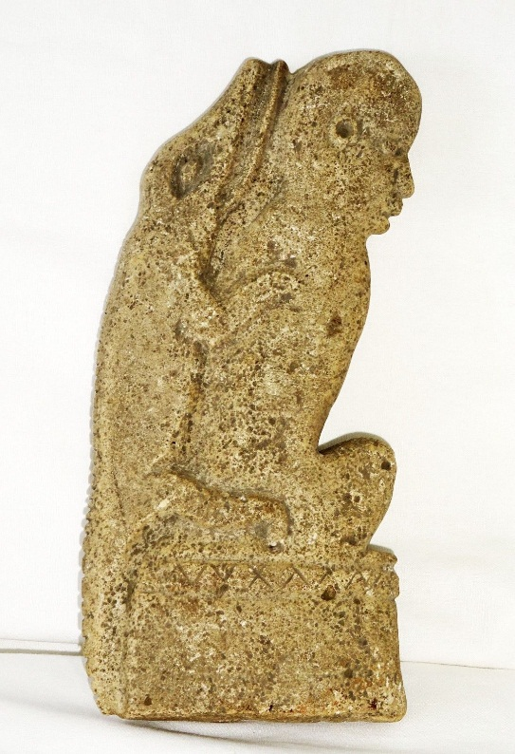 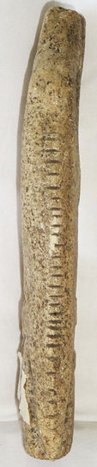

# **Formal Label:** Sumbanese Ancestral Limestone Figure with Crocodile Protector

**Accession Number:**

**LC Classification:**

**Date or Time Horizon: late 19th to** early 20th century

**Geographical Area:** Sumba Island, East Nusa Tenggara Province, Indonesia

**Cultural Affiliation:** Sumbanese Culture

**Medium:** Limestone

**Dimensions:** H 8.5 in, W 4 in

**Weight:**

**Provenance:** Andrès Harnisch, Honolulu, Hawaii, 2004.

**Condition:** Museum Quality

**Discussion:** The ancestraltombs and stone alters with crocodilesand other aquatic animals offer protectionto the deceased on the journey to *Prai Marapu*, a heavenly spirit world. To pay tribute to *Prai Marapu,* Sumbanese place effigies in the shape of ancestors and their animal protectors, such as the crocodile, like the Atlantika limestone figure above, in their gardens or inside their traditional thatch-roofed houses.

In Prai Marapu the spirits lead a human-like existence in couples and consist of two elements, *Ndewa* and *Hamanangu*, symbolized by the Great Mother (*Ina Kalada*) and the Great Father (*Ama Kalada*). They assume the forms of the moon and the sun, as husband and wife, who gave birth to the ancestors of the Sumbanese. Their power is great: They have a mysterious psychological influence over human life, in which they can project a psychosomatic image of life on the minds of people that encourages them to attain happiness by striving to achieve unity in harmony.

The existential impact of Prai Merapu, unity in harmony, on the East Sumbanese today is reflected in their building megalithic stone burial monuments in the center of clusters of their high peak thatched clan houses that earns them the distinction of being one of the last megalithic cultures on Earth

**References: The village from whence the sculpture came from.**

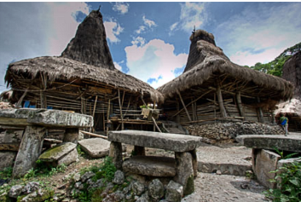

### **The Island of Sumba**

Sumba is an island in eastern [Indonesia](https://en.wikipedia.org/wiki/Indonesia). It is one of the [Lesser Sunda Islands](https://en.wikipedia.org/wiki/Lesser_Sunda_Islands), in the province of [East Nusa Tenggara](https://en.wikipedia.org/wiki/East_Nusa_Tenggara). Sumba has an area of 11,153 square kilometers (4,306 square miles) and a population of just over 600,000 people. It is nestled in the Indian ocean about 600 kilometers east of Bali and west of Timor island; an undulating, rugged green savannah with low limestone hills, knitted together by corn, cassava and rice fields in the interior, with spectacular windswept beaches along its coastline. The vistas in Sumba look unlike any other place in Indonesia; it has been observed that the topography looks more like Africa or parts of Australia than the volcanic islands that surround it. Geology has determined that Sumba is actually a piece of the Australian land mass that broke off and migrated through tectonic shifts over the last 120 million years.

The people of Sumba are among the last living examples of a vanishing megalithic culture, notable for its ancestor worship, hierarchical society and fierce sense of chivalry. Throughout the countryside, hilltop villages with high peak thatched clan houses are clustered around megalithic ancestral tombs. The Sumbanese are a horse riding people, famed over centuries for their sturdy, spirited horses and mammoth water buffalo. For at least two thousand years the Chinese, and subsequently Portuguese, Arab, Indian and Dutch traders, have been visiting Sumba’s shores to trade for sandalwood, spices, horses, and more… Headhunting was part of inter-village warfare until as late as the 1940s; however, widespread conversion to Christianity and modernization has rendered that practice a footnote to history.

Christianity is the dominant religion but an estimated 30% of the indigenous population adheres to the animist practice called Marapu. Despite the transition to Christianity, Marapu still exerts its hold through symbolic and ceremonial rites. Many Christians on the island combine their faith with animist practices. Marapu religion believes in temporary life on earth and an eternal life in the world of spirits in Marapu heaven (Prai Marapu). Marapu teaches that universal life must be balanced and only then can happiness be achieved. This balance is symbolized by the Great Mother (Ina Kalada) and the Great Father (Ama Kalada) who live in the universe and take the forms of the moon and the sun. They are husband and wife who gave birth to the first ancestors of the Sumbanese.

As in many animist religions, Marapu practitioners believe in a myriad of nature and animal spirits, and hold that spirit is dynamic and mutable in all things seen and unseen, present in important places such as the ancestral tombs and stone alters that give Sumba its uncanny megalithic atmosphere, and also in trees, rocks, and water.